**Select a screen from the link below.**

[**https://www.pinterest.com/r743780/sign-up-login/**](https://www.pinterest.com/r743780/sign-up-login/)

**Upload the image of the screen you selected in your Assignment-2 folder.**

**Design this screen in react native.**

**Upload the End result of your design in your repo.**

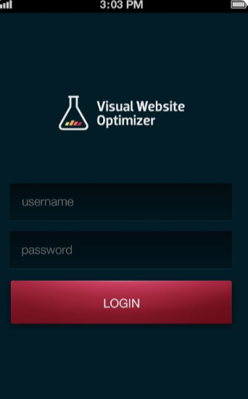

**Output:**

